Dev ops engineer apprenticeship

T. Rowe Price Portfolio

Aljilji, Arbnor

Arbnor.aljilji@troweprice.com

​Introduction to myself, team, and project

I am part of the T. Rowe Price Developer Services Group in London. We are a team of 9 Software Engineers, and 1 Product Manager that have different specialty skills as developers, SDETS and SREs. Our team looks after the developers who design apps, and our mission is to enable the developers to move as quickly as possible and enable them to push cleaner code at great frequency, and higher volume. Through automation around development tool chain, release management, software quality, builds, and developments, we aim to achieve these goals. Unity is an in-house product designed and looked after by DSG developers to allow other developers to deploy their application to the cloud, at a much quicker pace.

The project I am currently working on is a chatbot designed to automate any toil that our developers may experience. It will be available to only the DSG London and US team, which is a group of 20 engineers until further expansion. The chatbot itself will handle messages and requests from clients and respond back with an answer or resource. Many of our clients have repeated manual tasks such as opening a browser, writing a link to check merge requests, whereas the bot can notify the user with the merge request link upon request and the status of the merge request. There are other designed functions that myself and a project lead are working on for the bot to complete, as this will remove any toil the team undergoes. The value this chatbot project will bring to the team is by saving themselves a couple minutes a day, to several hours a week in total of typing and clicking in which the bot can perform at a higher rate with a simple question. As well as this project, the team and myself also provide Linux Desktop Support for developers.

*Duty 1 – Script and code in one general purpose language and one domain-specific language*

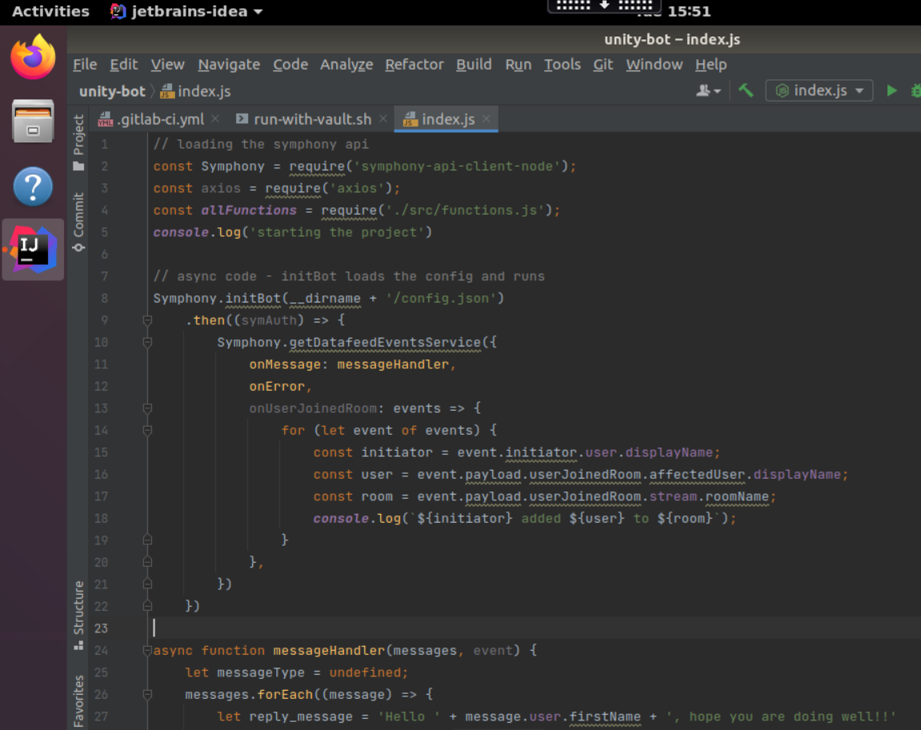

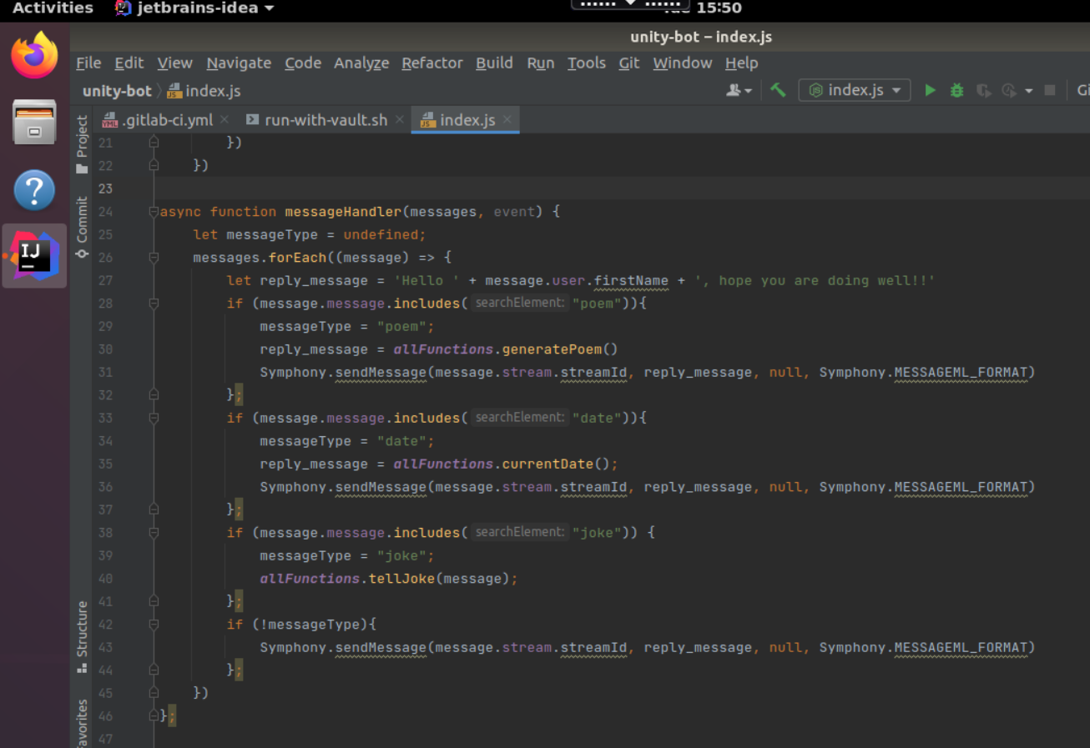

Above is the code for the index.js file which needs to be run to initiate the bot in the symphony-test environment. This will run locally to where I can test the app itself. It is written in NodeJS. Line 2 – 4 requires libraries and files which are to be used in the Index.js file. Line 24 – 46 is the function that listens to the user input in the Symphony chat, and it’ll respond according to the input.

Domain-specific language evidence to be shown in next submission.

*Duty 2 – Initiate and facilitate knowledge sharing and technical collaboration with teams and individuals, with a focus on supporting development of team members*

*Duty 3 – Engage in productive pair/mob programming to underpin the practice of peer review*

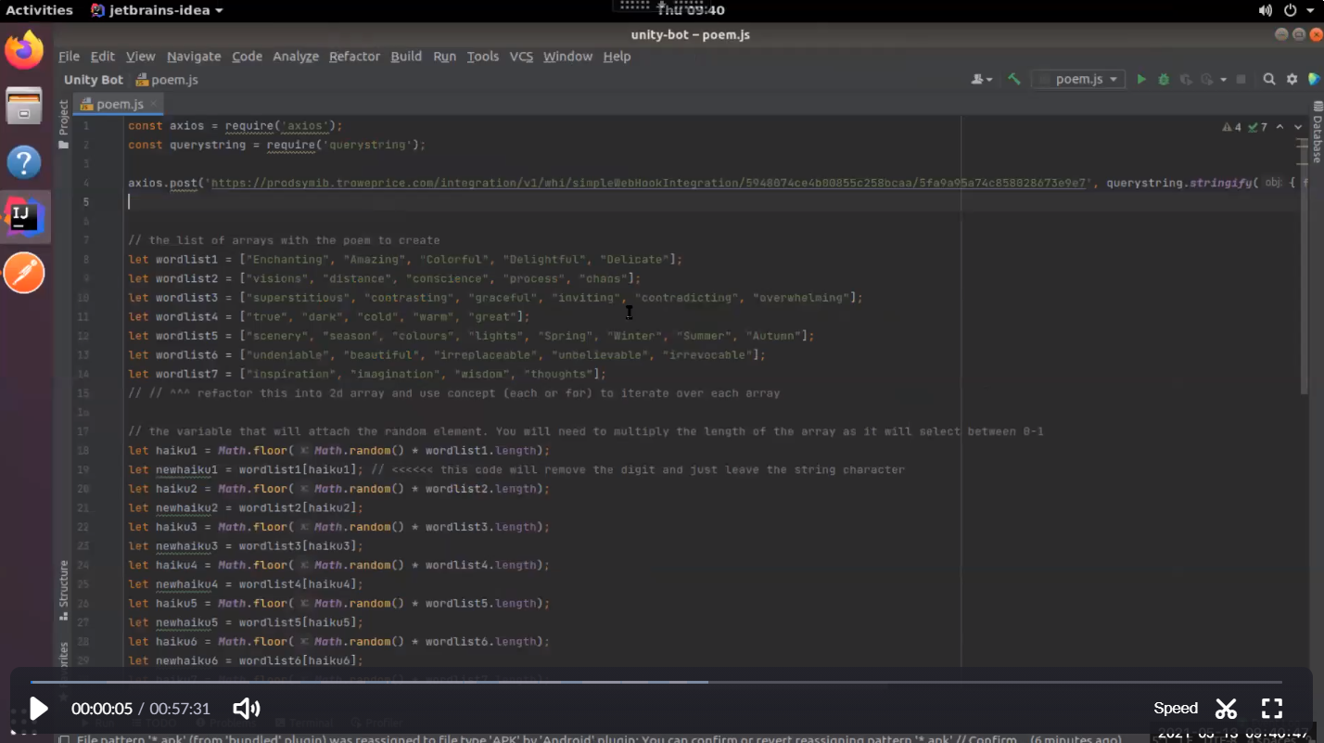

This is a Zoom recording of me and my project lead Ed Rowley pair programming and reviewing my code. This is the start of the video where Ed looks at my code and corrects and we refactor my code.

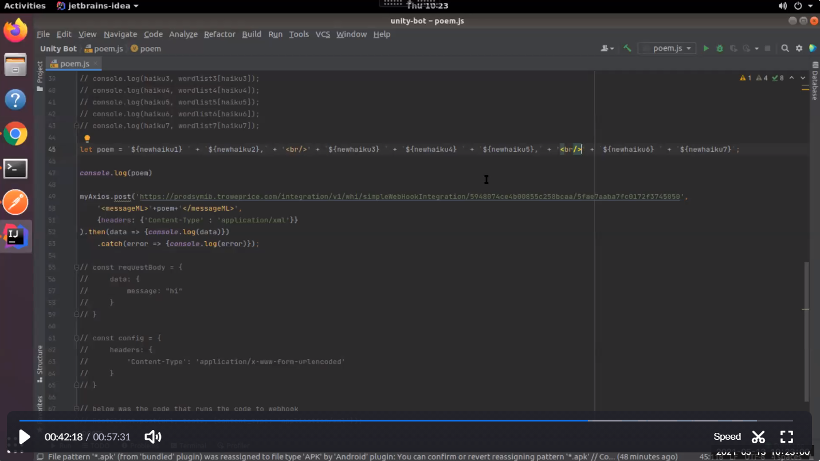

The screenshot above is the refactored code after 40 minutes of pairing and coding. The result is that we managed to change some of my code, and change drivers in the coding.

*Duty 4 – Work as part of an agile team, and explore new ways of working, rapidly responding to changing users needs and with a relentless focus on the user experience. Understand the importance of continual improvement within a blameless culture*

Note for myself below:

(Example will be: xmatters shifts)

*Duty 5 – Build and operate a Continuous Integration (CI) capability, employing version control of source and related artefacts*

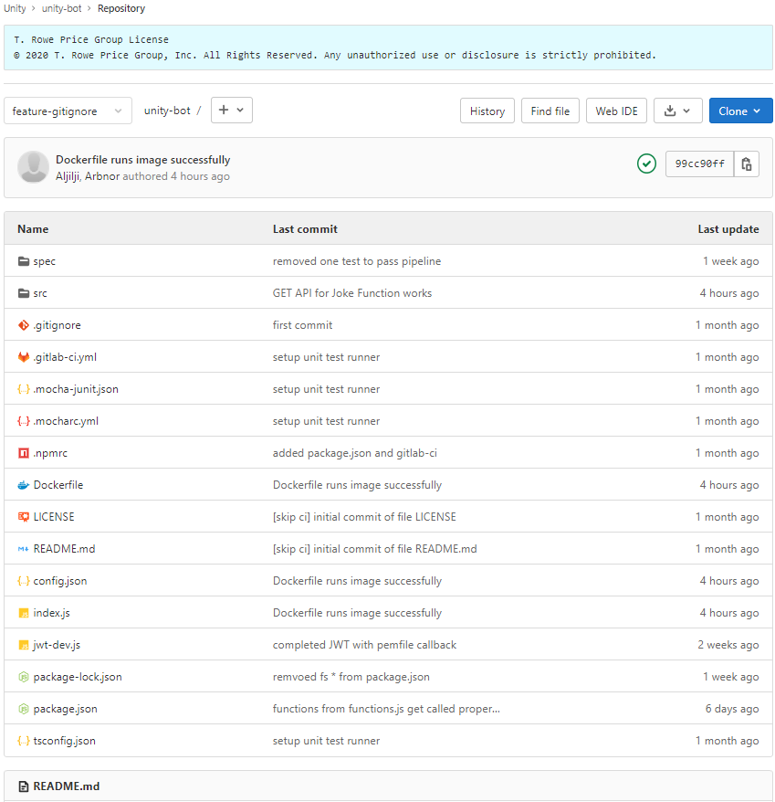

Above is my version source control for my project Unity-Bot

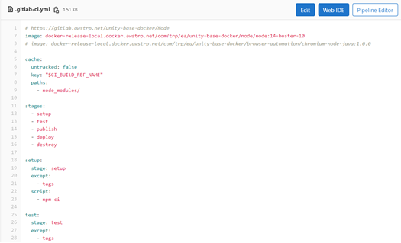

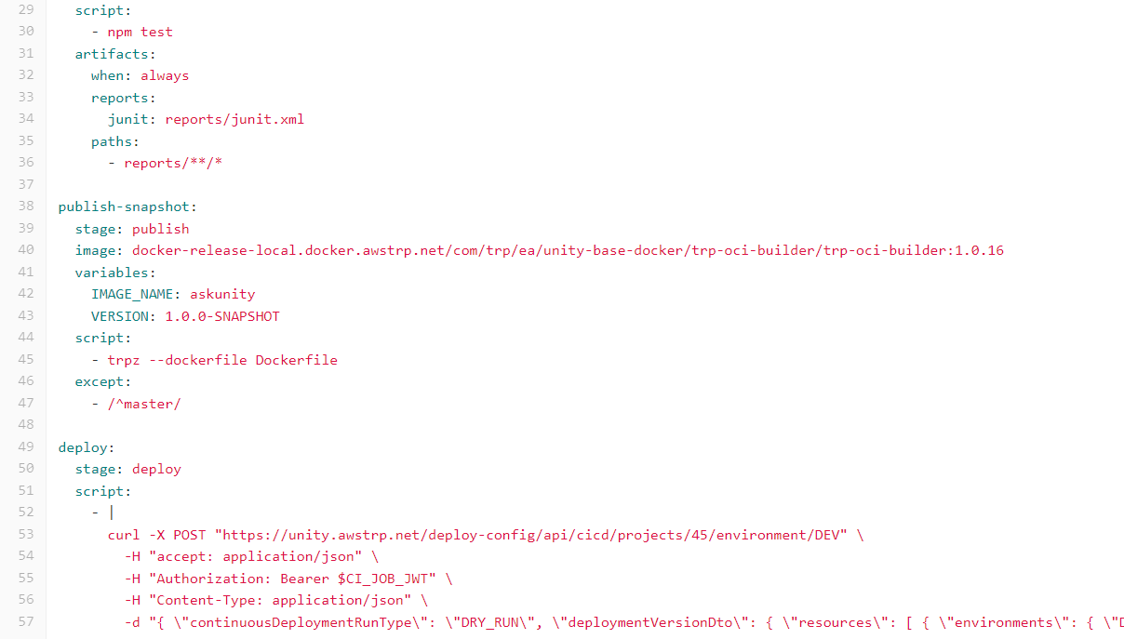

Above is my gitlab-ci.yml file which sets up the CI/CD pipeline in gitlab which consists so far of setup, test, publish, and deploy.

*Duty 6 – Implement and improve release automation & orchestration, often using Application Programming Interfaces (API), as part of the continuous delivery and continuous deployment pipeline, ensuring that team(s) can deploy new code rapidly and safely*

Note to self below:

*Pipeline update: - when pipeline completes, calls API to Unity Bot and notif a user with the completion – maybe using a previous webhook    
   
(maybe John Singh – add additional decorations to MR) <<< after Unity bot*

*Duty 7 – Provision cloud infrastructure using APIs, continually improve infrastructure-as-code, considering using industry leading technologies as they become available (e.g. Serverless, Containers)*

Note to self below:

*FarGate as a service <<<*

*(use lambda?)*

*Unity Deploy Open Source contribution model < Continually improve IaC << using the confluence page that I saw with Ed for terraform tests etc*

*Maybe Chris*

*Duty 8 – Evolve and define architecture, utilizing the knowledge and experience of the team to design in an optimal user experience, scalability, security, high availability and optimal performance*

Note to self below:

*Moving from ec2 to fargate < evolution progress (scalability, disk space, handling secrets (previously hard coded, by now it’s in Vault – authentication based on AWS IAM))*

*Duty 9 – Apply leading security practices throughout the Software Development Lifecycle (SDLC)*

1. We don’t expose secrets to pipeline (gitlab JWT to authenticate deploy)
2. We removed pem secret hard code, and managed outside its own secret context as seen below in Vault



1. All dependences are pulled via artifactory (trusted source), and artifactory scans the containers that are being produced and checks for security vulnerabilities. There are 2 main things about artifactory:

* All dependences get pulled through artifactory and not going out to the internet to untrusted sources.
* Artifactory can scan the things that we produce and check the containers to make sure there are no known vulnerabilities in them.

1. TEA & Fortify – automatic scanning to check the quality of the code. Fortify (static code analyse) will raise issues if it detects code that is not properly sanitizing user input. It will produce a report to highlight that its not happy with this approach etc.



*Duty 10 – Implement a good coverage of monitoring (metrics, logs), ensuring that alerts are visible, tune-able and actionable*

Note for self below:

*(Can’t do this yet – AWS*

*Logs in CloudWatch)*

*Duty 11 – Keeping up with cutting edge by committing to continual training and development – utilize web resources for self-learning; horizon scanning; active membership of professional bodies*

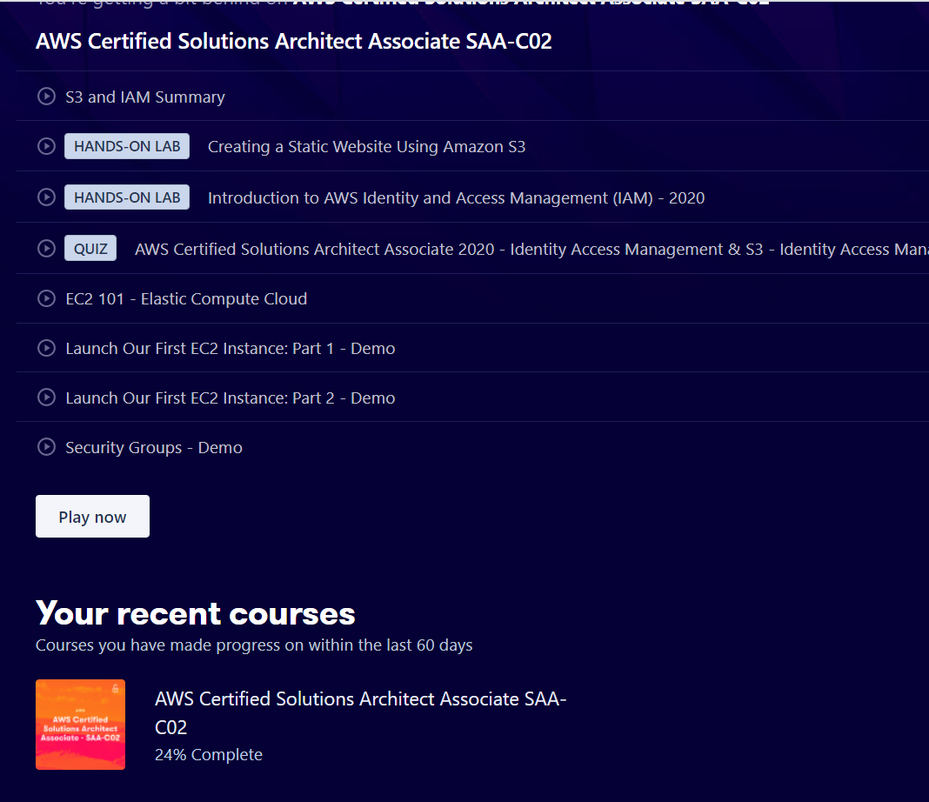

24% of the AWS SAA studied so far – currently doing around 1hour a day of learning regarding AWS (and creating my own documentation on it)

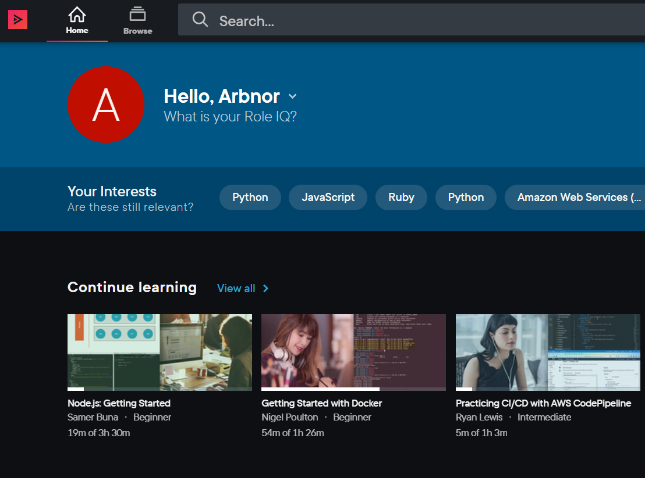

I also have PluralSight – currently not using it as I am learning AWS and NodeJs

**

I have access to Udemy business where I can access and I’m currently learning NodeJS

*Duty 12 – Look to automate any manual tasks that are repeated, often using APIs*

Note to self below:

*(We are currently working to remove a simple manual task of looking at the rota shift of who is on current support.)*

*Duty 13 – Accept ownership of changes; embody the DevOps culture of ‘you build it, you run it, with a relentless focus on the user experience*

Note to self below:

*(Supporting your own app – you will need to update it/or improve it due to user needs)*